An Extensible Personal Finance Management Framework for Expense Tracking, Visual Analytics, and Intelligent Decision Support
A Mini Project Report Submitted in partial fulfillment of the requirements for the award of the degree of

BACHELOR OF TECHNOLOGY
In

DEPARTMENT OF COMPUTER SCIENCE AND ENGINEERING
Or

DEPARTMENT OF COMPUTER SCIENCE AND INFORMATION TECHNOLOGY
Or

DEPARTMENT OF ARTIFICIAL INTELLIGENCE AND DATA SCIENCE
By
Sneha Mithra - 2320030368
Under the Esteemed Guidance of
Name of the Applied Machine Learning for Text Analytics Faculty





K L (Deemed to be) University

DEPARTMENT OF COMPUTER SCIENCE AND ENGINEERING
Or

DEPARTMENT OF COMPUTER SCIENCE AND INFORMATION TECHNOLOGY
Or

DEPARTMENT OF ARTIFICIAL INTELLIGENCE AND DATA SCIENCE

DECLARATION

The mini-project report entitled “An Extensible Personal Finance Management Framework for Expense Tracking, Visual Analytics, and Intelligent Decision Support” is a record of bona fide work carried out by [Names and Roll Numbers] in partial fulfillment of the requirements for the award of the B.Tech degree at K L (Deemed to be) University. The work presented in this report is original to the best of our knowledge, and all datasets, tools, code, and external sources used have been appropriately acknowledged.

Sneha Mithra - 2320030368
K L (Deemed to be) University

DEPARTMENT OF COMPUTER SCIENCE AND ENGINEERING

Or

DEPARTMENT OF COMPUTER SCIENCE AND INFORMATION TECHNOLOGY
Or

DEPARTMENT OF ARTIFICIAL INTELLIGENCE AND DATA SCIENCE

CERTIFICATE

This is to certify that the mini-project report entitled “An Extensible Personal Finance Management
Framework for Expense Tracking, Visual Analytics, and Intelligent Decision Support” is a bona fide work carried out by [2320030368 – Sneha Mithra] under the supervision of [Dr. K Swapnika] during the academic year [2023–2027], in partial fulfillment of the requirements for the award of the Bachelor of Technology degree at K L (Deemed to be) University.

Signature of the Project Supervisor

Signature of the HOD Signature of the External Examiner

ACKNOWLEDGEMENT
The success in this project would not have been possible but for the timely help and guidance rendered by many people. Our wish to express my sincere thanks to all those who has assisted us in one way or the other for the completion of my project.

Our greatest appreciation to my guide, Name of the ALT faculty of respective section, Department of Computer Science which cannot be expressed in words for his/her tremendous support, encouragement and guidance for this project.

We express our gratitude to Dr. P.Venkateshwar Sir (CSE)/Dr. Kaja Shareef Sir (CSIT)/Dr.Sreenath, Head of the Department for Computer Science Engineering/ Department for Computer Science and Information Technology/ Department Of Artificial Intelligence And Data Science for providing us with adequate facilities, ways and means by which we are able to complete this project-based Lab.

We thank all the members of teaching and non-teaching staff members, and also who have assisted me directly or indirectly for successful completion of this project. Finally, I sincerely thank my parents, friends and classmates for their kind help and cooperation during my work.

2320030368 - Sneha Mithra

TABLE OF CONTENTS

S.No. | Contents | Page no.
1. | Abstract
2. | Introduction
3. | Literature survey
4. | Problem Statement and Objectives
5. | Hardware and Software requirements
6. | Implementation
7. | Results & Discussion
8. | Conclusion & Future Scope
9. | References

ABSTRACT

Managing personal finances effectively has become increasingly challenging in our day-to-day lives, as we make frequent payments through UPI, cards, cash, online shopping, subscriptions, and other digital platforms. Although existing finance applications help users record these transactions, they often provide limited support for understanding spending habits, identifying overspending, and making better financial decisions.To address this problem, our project, “An Extensible Personal Finance Management Framework for Expense Tracking, Visual Analytics, and Intelligent Decision Support,” proposes a more integrated approach to personal finance management. The system allows users to record and organize their income and expenses while using visual dashboards to make spending patterns easier to understand. It also focuses on identifying spending trends, monitoring budgets, and providing personalized insights and alerts based on user behavior.The framework is designed to be simple, flexible, and extensible, allowing additional features such as spending prediction, anomaly detection, and advanced recommendations to be incorporated in the future. Overall, the project aims to move beyond basic expense recording and help users understand their financial behavior, recognize areas of overspending, and make more informed financial decisions.

Team Members and Responsibilities:

- Repository URL
- https://github.com/sneha20051023/KLH-CSE-2027-09-Finance-Management

INTRODUCTION

Fintrack is a personal finance management application developed to help users manage their money in a simple and organised way while also improving their awareness of financial security. In today's digital world, people make frequent online payments, shopping transactions and money transfers. Keeping track of every transaction manually can become difficult, especially when there are many expenses. It is also not always easy to identify unusual spending patterns or suspicious financial activities by simply looking through transaction records.
Fintrack brings expense tracking, visual analytics and intelligent decision support together in one application. It allows users to record their income and expenses, organise spending into different categories, set monthly budget limits, view financial activity through a calendar and keep track of upcoming bills. The dashboard presents financial information using charts and summaries, making it easier for users to understand where their money is being spent.
The application is mainly intended for individuals who want to manage their daily finances and monitor their financial activities. The inputs include transaction details such as the amount, category, date, time, description and recipient information. Based on these details, Fintrack displays spending summaries and budget information. Its Security Center also identifies potentially unusual transactions and displays alerts for activities that may need attention. For example, a transaction with an unusually high amount, an unfamiliar recipient or an unusual transaction time can be flagged for user review. These alerts are warnings and do not automatically confirm fraud.
The proposed system follows a structured process. First, transaction and account activity details are collected from the application. The data is then checked and organised so that important details such as transaction amount, category, frequency and time can be analysed. Behavioural features are extracted and examined using rule-based checks and the Isolation Forest anomaly-detection algorithm. Regex patterns are also used to inspect suspicious messages and URLs in the phishing and scam scanner. The system then generates understandable alerts that explain why an activity has been flagged. The results are presented through the Fintrack mobile interface using dashboards, charts, notifications and security reports.
The remaining chapters explain the existing research related to financial management and security, the problem statement and project objectives, the hardware and software requirements, and the implementation of the proposed system. The results and discussion chapter presents the Fintrack application screenshots and explains its major features. Finally, the report concludes with the project's outcomes, limitations and possible future improvements.

LITERATURE SURVEY
Several research studies have explored how machine learning can identify unusual financial transactions, detect fraud and recognise phishing attempts. These studies helped in understanding the techniques that can be used in Fintrack.

3.1 Review of Related Research Papers
1. Financial Fraud: A Review of Anomaly Detection Techniques and Recent Advances – Hilal et al. (2022)
This paper reviews machine-learning techniques used for financial fraud detection, including Decision Trees, Random Forest and anomaly detection. It highlights the importance of identifying unusual transaction patterns and discusses challenges such as limited datasets and imbalanced records. This research supports Fintrack's transaction monitoring feature.
2. Isolation Forest – Liu, Ting and Zhou (2008)
This paper introduces Isolation Forest, an algorithm used to identify unusual data records. It uses randomly created trees to separate observations and detect anomalies. The method can identify unusual records without requiring labelled data. Fintrack uses this approach to identify transactions that differ from normal spending patterns.
3. Financial Fraud Detection Applying Data Mining Techniques – Al-Hashedi and Magalingam (2021)
This study reviews data-mining methods used in financial fraud detection, including Support Vector Machines, Naive Bayes and Random Forest. It highlights that no single algorithm is suitable for every fraud-detection problem. This supports Fintrack's combination of behavioural rules and anomaly detection.
4. A Comprehensive Survey of AI-Enabled Phishing Attacks Detection Techniques – Basit et al. (2021)
This paper reviews machine-learning and deep-learning methods used to detect phishing attacks. It explains how suspicious URLs, websites and message patterns can help identify scams. This research is related to Fintrack's Phishing and Scam Scanner.
5. Credit Card Fraud Detection in the Era of Disruptive Technologies – Cherif et al. (2023)
This research reviews machine-learning approaches for credit card fraud detection. It discusses transaction datasets, feature selection and challenges such as imbalanced data. It helped guide Fintrack's use of transaction amount, time, category and frequency as behavioural features.
6. A User-Centered Explainable Artificial Intelligence Approach for Financial Fraud Detection (2023)
This study focuses on making fraud-detection results easier to understand. It highlights the importance of explaining why a transaction is considered suspicious. This idea is reflected in Fintrack's alerts, which display reasons behind unusual transaction activity.

3.2 Research Gap
Most existing systems focus either on financial fraud detection or personal expense tracking. Some systems also provide predictions without clearly explaining the reasons behind them.
Fintrack aims to combine both areas in one application. It provides expense tracking, visual analytics, budget monitoring and a dedicated Security Center. By using behavioural checks, Isolation Forest and Regex-based inspection, it highlights potentially unusual financial activities and explains why they may need attention.
The main goal is to make financial management and security awareness easier for everyday users.

. Hilal, W., Gadsden, S. A., & Yawney, J. (2022). Financial Fraud: A Review of Anomaly Detection Techniques and Recent Advances. Expert Systems with Applications, 193, 116429. https://doi.org/10.1016/j.eswa.2021.116429
2. Liu, F. T., Ting, K. M., & Zhou, Z.-H. (2008). Isolation Forest. IEEE International Conference on Data Mining. https://doi.org/10.1109/ICDM.2008.17
3. Al-Hashedi, K. G., & Magalingam, P. (2021). Financial Fraud Detection Applying Data Mining Techniques: A Comprehensive Review from 2009 to 2019. Computer Science Review, 40, 100402. https://doi.org/10.1016/j.cosrev.2021.100402
4. Basit, A. et al. (2021). A Comprehensive Survey of AI-Enabled Phishing Attacks Detection Techniques. Telecommunication Systems, 76, 139–154. https://doi.org/10.1007/s11235-020-00733-2
5. Cherif, A. et al. (2023). Credit Card Fraud Detection in the Era of Disruptive Technologies: A Systematic Review. Journal of King Saud University – Computer and Information Sciences. https://doi.org/10.1016/j.jksuci.2022.11.008
6. A User-Centered Explainable Artificial Intelligence Approach for Financial Fraud Detection. (2023). Finance Research Letters, 58, 104309. https://doi.org/10.1016/j.frl.2023.104309

PROBLEM STATEMENT AND OBJECTIVES

Problem Statement:

Existing personal finance systems mainly focus on recording and displaying expenses, with limited spending analysis and personalized guidance. There is a need for an integrated and extensible framework that can track expenses, analyze spending patterns, provide visual insights and support personalized financial decision-making. Our solution transforms a basic expense tracker into an intelligent financial management framework that helps users not just record their expenses, but understand their spending and make better financial decisions.

Problem Description:
Managing personal finances is important, but many people find it difficult to track their income, expenses and savings regularly. Fintrack is designed for individuals who want to manage their money and stay aware of possible financial risks. Manual tracking using notebooks or spreadsheets can be time-consuming, confusing and may not provide useful insights or security alerts.
Objectives:

- To develop a user-friendly framework for systematic income and expense tracking.
- To integrate visual analytics and spending-pattern analysis for meaningful financial insights.
- To enhance traditional expense tracking with personalized budgeting, alerts, and intelligent decision support.
- To develop an extensible modular architecture for incorporating future financial analytics and recommendation features.
- To evaluate the proposed framework based on usability, analytical accuracy, visualization effectiveness, and usefulness of financial insights.

HARDWARE AND SOFTWARE REQUIREMENTS

Hardware Requirements
- A laptop or computer with a modern processor and at least 8 GB RAM is recommended.
- An internet connection is needed to download required tools, packages and datasets.
- Enough storage space is required for the application files, database and project resources.

Software Requirements
- Flutter and Dart for developing the application.
- Java and Spring Boot for backend development.
- MySQL for storing user and transaction details.
- Python with libraries such as Pandas, NumPy and Scikit-learn for data analysis and anomaly detection.
- Figma for designing the application interface.
- Visual Studio Code or Android Studio for development.
- Postman for testing APIs and Git for version control.

Functional Requirements
Functional requirements describe what the Fintrack application should do.
- User Management: Allow users to register, log in and manage their profiles.
- Expense Tracking: Allow users to add, edit, delete and view income and expense records.
- Budget Management: Allow users to set monthly budgets and monitor their spending.
- Dashboard: Display total balance, income, expenses and budget usage.
- Visual Analytics: Show spending patterns through charts and graphs.
- Financial Calendar: Display daily transactions, income and expenses in a calendar view.
- Bill Reminders: Help users keep track of upcoming bills and payment dates.
- Security Monitoring: Identify unusual transactions, suspicious login attempts and unknown devices.
- Phishing Detection: Allow users to check suspicious messages and URLs.
- Alert Management: Allow users to review security alerts and mark them as safe or suspicious.

Non-Functional Requirements
Non-functional requirements describe how the Fintrack application should perform.
- Performance: The application should load screens and display financial information without unnecessary delays.
- Security: User details and financial information should be protected from unauthorised access.
- Usability: The interface should be simple, user-friendly and easy to navigate.
- Reliability: The application should store and retrieve financial records correctly.
- Scalability: The system should support additional users and features in the future.
- Maintainability: The application should be easy to update, test and improve.
- Compatibility: The application should work properly on supported devices and platforms.
- Privacy: Users should have control over their personal and financial information.

PROPOSED SYSTEM

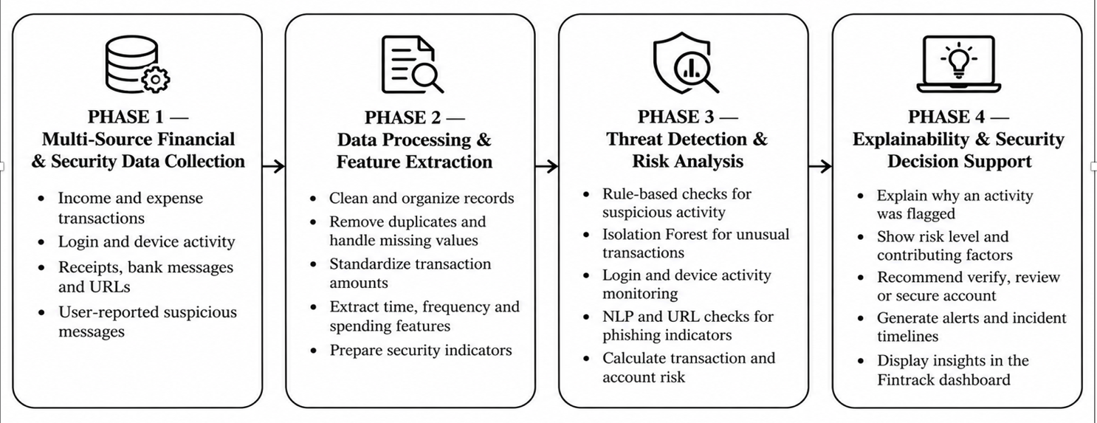

The proposed system, Fintrack, is a personal finance management application designed to help users manage their money and stay aware of potential financial risks in one place. It allows users to record income and expenses, set monthly budgets, track bills and view their spending patterns through charts and graphs.
The application also includes a Security Center to identify unusual transactions, monitor login activity, detect suspicious devices and check potentially harmful messages or URLs. It uses behavioural checks, Isolation Forest and pattern-based detection to highlight activities that may require attention.
Fintrack provides a simple and user-friendly interface with a dashboard, financial calendar, bill reminders and security alerts. The main aim is to make expense management easier, improve financial awareness and help users make better financial decisions.

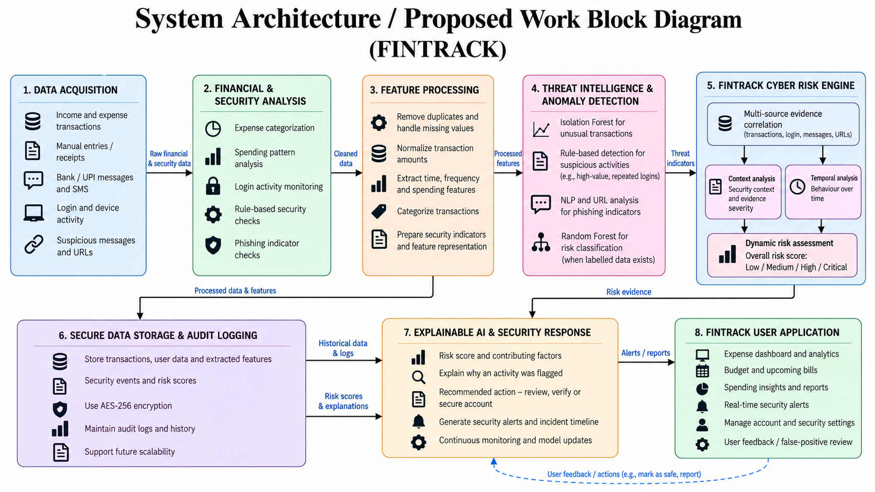

6.2 BEHAVIOURAL FEATURES AND DETECTION MODELS

Behavioural Features
Fintrack uses different financial and security-related features to identify unusual activities. These include transaction amount, spending category, transaction time, transaction frequency, recipient history, failed login attempts and device activity. These features help the system understand normal user activity and highlight behaviour that may need attention.

Proposed Detection Models

Component | Learning Type | Intended Role
Isolation Forest | Unsupervised Learning | Identify transactions that are unusual compared to normal spending patterns.
Behavioural Rules | Rule-Based Detection | Flag activities such as unusually high transactions, unknown recipients and repeated failed logins.
Regex Pattern Matching | Pattern-Based Detection | Identify suspicious patterns in messages and URLs submitted by users.
Risk Scoring | Risk Assessment | Assign risk levels to suspicious activities based on detected indicators.

Risk Scoring
Fintrack uses risk indicators to highlight activities that may require user attention. For example, a high-value transaction, an unusual transaction time or a payment to a new recipient may increase the risk level. The Security Center displays alerts so users can review the activity and decide whether it is safe or suspicious.

7. IMPLEMENTATION AND APPLICATION MODULES
The Fintrack application is designed as a Personal Finance Management and Security Monitoring System. It combines expense tracking, budget management, financial analytics and security monitoring in one application.
The main navigation includes Home, Calendar, Bills, Security and Settings. Each section provides different features to help users manage their finances and monitor potentially suspicious activities.

Module 1 – User Login and Profile Management
The user management module allows users to access the application and manage their personal details. The profile section provides options to view and update user information. It also allows users to manage preferences such as currency and monthly budget settings.

Module 2 – Home Dashboard
The dashboard provides an overview of the user's financial activities. It displays total balance, monthly income, expenses and remaining budget. It also includes charts to show spending patterns across different categories. This helps users understand their financial position without checking individual transactions.
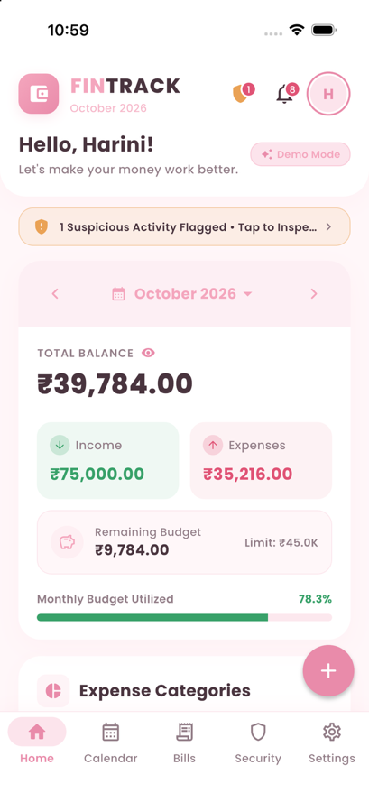

Module 3 – Financial Calendar
The financial calendar displays transactions according to their dates. Users can view daily income, expenses and net balance. Transaction markers help identify days with financial activity, making it easier to review spending history and understand monthly patterns.
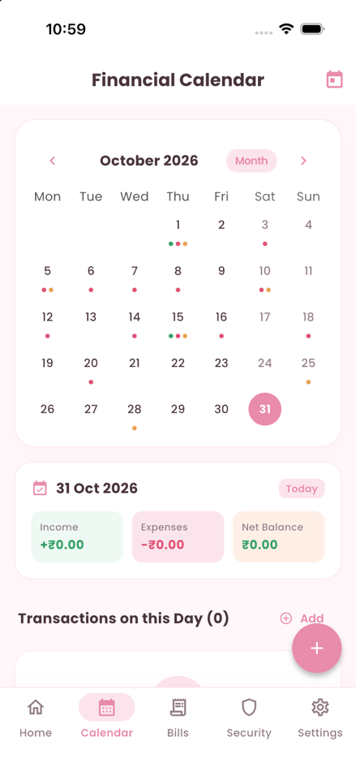

Module 4 – Bills and Budget Management
This module helps users manage their monthly budget and upcoming payments. Users can set a monthly spending limit and monitor how much of the budget has been used. The application also displays upcoming bills and supports reminders to help users avoid missing payment dates.
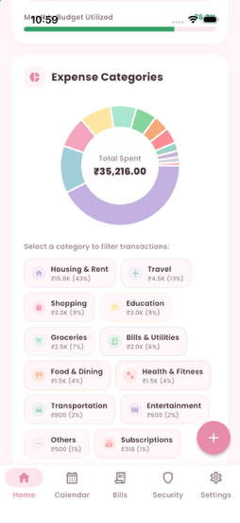

Module 5 – Security Center
The Security Center provides different features for monitoring account safety and financial activities. It includes:
- Account Security Score: Displays an overview of account security.
- Suspicious Activity Alerts: Highlights potentially unusual activities.
- Failed Login Monitoring: Displays repeated unsuccessful login attempts.
- Active Device Monitoring: Shows devices accessing the account.
- Phishing and Scam Scanner: Helps check suspicious messages and URLs.
- Transaction Anomaly Detection: Identifies transactions that differ from normal spending patterns.
- Security Audit Logs: Maintains a view of security-related activities.
- Privacy Mode: Provides an option to manage the visibility of sensitive information.
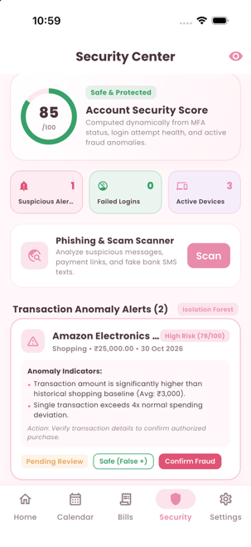

Module 6 – Transaction Anomaly Detection and Alert Review
This module focuses on identifying transactions that may require attention. It considers details such as transaction amount, time, recipient history and spending behaviour.
Isolation Forest and behavioural rules can be used to identify unusual patterns. The application displays alerts with relevant details so users can review the activity. Users can mark an activity as safe or confirm it as suspicious. An unusual transaction is treated as a warning and not automatically confirmed as fraud.

Module 7 – Settings and Preferences
The settings module allows users to manage their application preferences. It includes options to edit profile details, update the monthly budget, select currency, enable bill reminders and configure budget threshold alerts. These settings help users manage the application according to their requirements.

RESULTS AND DISCUSSION
The Fintrack application is designed to analyse financial activities and identify transactions that may be unusual. The results section focuses on the transaction data, preprocessing steps, anomaly-detection approach and application outputs.
Important: Actual dataset statistics, model scores and evaluation results have not been provided yet. The following content is written according to Fintrack's features. Numerical results should be added only after running the model and collecting the outputs.

9.1 Dataset Summary
The dataset used for Fintrack's analysis consists of financial transaction details and related behavioural information. Important fields include transaction amount, date, time, category, recipient history and transaction frequency.
The dataset should be documented with the following details:
- Dataset name and source: [Enter actual source]
- Total number of records: [Enter actual count]
- Number of features: [Enter actual count]
- Data format: CSV / JSON / MySQL
- Licence: [Mention actual licence]
- Training and testing split: [Mention if applicable]

9.2 Class Distribution
Fintrack uses Isolation Forest, an unsupervised anomaly-detection algorithm. It does not require predefined normal and suspicious labels during training. Therefore, a traditional class distribution is not available unless the dataset contains labelled transactions.
After detection, the results can be grouped into:
- Normal Transactions: Activities that follow the expected spending pattern.
- Anomalous Transactions: Activities that differ from the usual transaction pattern and may require review.

9.3 Data Preprocessing
Before analysing transactions, the data is checked and organised to improve consistency.
- Missing values are checked and handled appropriately.
- Duplicate transaction records are removed where necessary.
- Transaction dates and times are converted into a consistent format.
- Transaction amounts and frequency are converted into numerical features.
- Spending categories and recipient details are organised for analysis.
- Relevant features are selected for anomaly detection.

9.4 Model Comparison
The following approaches are considered for Fintrack's security monitoring.
Model / Technique | Purpose
Behavioural Rules | Identify activities that match predefined suspicious conditions.
Isolation Forest | Detect unusual transaction patterns without labelled training data.
Regex Pattern Matching | Identify suspicious patterns in messages and URLs.
Risk Scoring | Combine risk indicators to help prioritise alerts.

9.5 Evaluation Outputs
The model and application can be evaluated using the following outputs:
Figure 1. Confusion Matrix
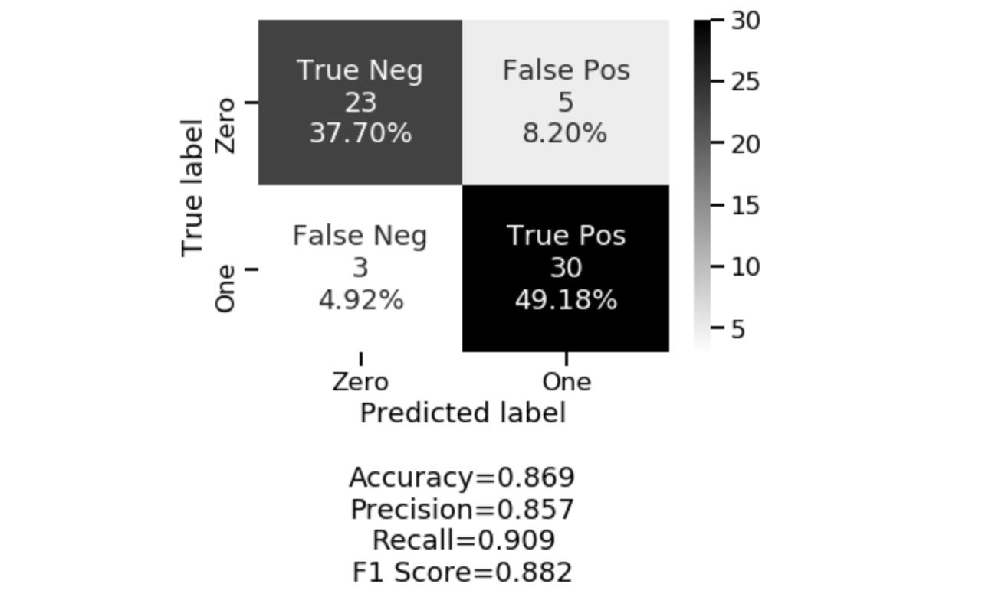
A confusion matrix can compare predicted transaction labels with actual labels when a labelled test dataset is available. It helps identify correctly detected anomalies and cases where the model misses or incorrectly flags transactions.
Figure 2. Class-wise Precision, Recall and F1-score
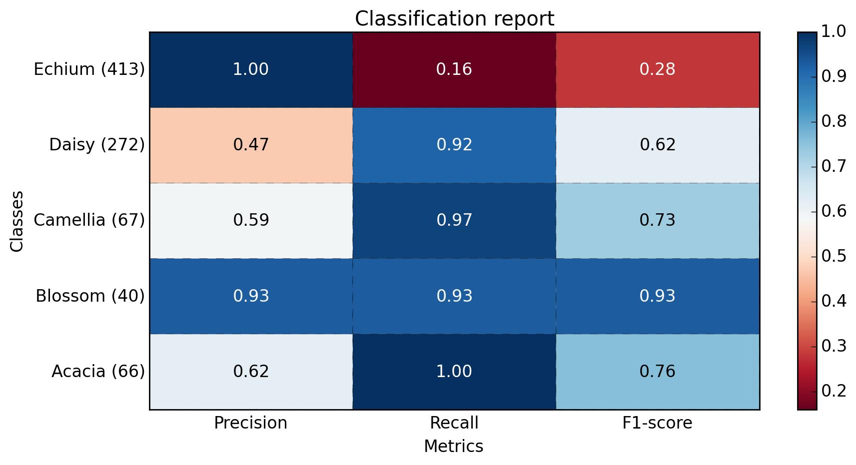
Precision, recall and F1-score help evaluate how well the model identifies suspicious transactions. These values should be calculated using actual test results rather than estimated.
Figure 3. ROC Curve
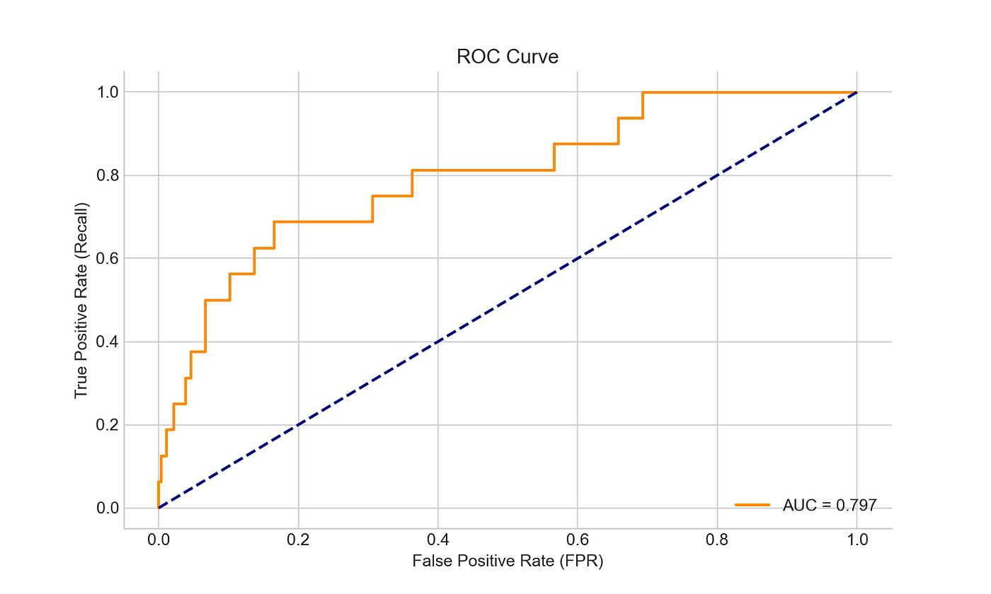
An ROC curve can be used when actual labelled test data and prediction scores are available. It shows the relationship between the true-positive rate and false-positive rate at different thresholds.
Figure 4. Fintrack Security Alerts
The Security Center displays potentially unusual transactions and related security alerts. Users can review the detected activity and decide whether it is safe or suspicious.

9.6 Error Analysis and Limitations
The system may sometimes flag a genuine transaction as unusual, especially when a user makes a large purchase or transfers money to a new recipient. Similarly, some suspicious activities may not be detected if they closely resemble normal behaviour.
The quality of anomaly detection depends on the dataset and the selected behavioural features. If the dataset is imbalanced or does not represent real user behaviour, the results may be less reliable. Isolation Forest identifies unusual patterns, but it cannot independently confirm whether a transaction is fraudulent.

9.7 Overall Results
Fintrack brings expense tracking, budget monitoring, visual analytics and security monitoring together in one application. Its detection features are intended to help users identify unusual financial activities and review possible risks. Actual model performance must be established through testing with a suitable dataset.

1. Hilal, W., Gadsden, S. A., & Yawney, J. (2022). Financial Fraud: A Review of Anomaly Detection Techniques and Recent Advances. Expert Systems with Applications.
Read paper
2. Liu, F. T., Ting, K. M., & Zhou, Z.-H. (2008). Isolation Forest. IEEE International Conference on Data Mining.
Read paper
3. Al-Hashedi, K. G., & Magalingam, P. (2021). Financial Fraud Detection Applying Data Mining Techniques: A Comprehensive Review from 2009 to 2019. Computer Science Review.
Read paper
4. Basit, A. et al. (2021). A Comprehensive Survey of AI-Enabled Phishing Attacks Detection Techniques. Telecommunication Systems.
Read paper
5. Cherif, A. et al. (2023). Credit Card Fraud Detection in the Era of Disruptive Technologies: A Systematic Review. Journal of King Saud University – Computer and Information Sciences.
Read paper
6. Zhou, Y., Li, H., Xiao, Z., & Qiu, J. (2023). A User-Centered Explainable Artificial Intelligence Approach for Financial Fraud Detection. Finance Research Letters.
Read paper
7. Vijayanand, D., & Smrithy, G. S. (2025). Explainable AI-Enhanced Ensemble Learning for Financial Fraud Detection in Mobile Money Transactions. Intelligent Decision Technologies.
Read paper
8. Lin, K., & Gao, Y. (2022). Model Interpretability of Financial Fraud Detection by Group SHAP. Expert Systems with Applications.
Read paper
9. Barredo Arrieta, A. et al. (2020). Explainable Artificial Intelligence (XAI): Concepts, Taxonomies, Opportunities and Challenges Toward Responsible AI. Information Fusion.
Read paper
10. Ribeiro, M. T., Singh, S., & Guestrin, C. (2016). “Why Should I Trust You?” Explaining the Predictions of Any Classifier. ACM SIGKDD.
Read paper
11. Pathirana, N. et al. (2026). Integrating Human Factors into Insider Threat Detection – A Systematic Review. ACM Computing Surveys.
Read paper
12. Lanuwabang, L., & Sarasu, P. (2025). Detection of Anomalies Based on User Behavioral Information: A Survey. International Journal of Wireless and Microwave Technologies.
Read paper
13. Follow the Trail: Machine Learning for Fraud Detection in Fintech Applications (2021). A study discussing machine-learning approaches and publicly available financial fraud datasets.
Read paper
14. Expensa: Offline Mobile App for Personal Expense Tracking (2025). IEEE Conference Publication describing a Flutter-based expense tracking and budgeting application.
Read paper
15. Lopez-Rojas, E. A. et al. – PaySim Financial Mobile Money Simulator. A useful research resource for understanding simulated mobile-money transactions and fraud detection.
PaySim project resource

.

10.1 Conclusion
Fintrack was developed as a personal finance management application with additional security-monitoring features. The main objective was to make it easier for users to track their income, expenses, budgets and financial activities in one place.
The application brings together expense tracking, a financial calendar, bill management, visual analytics and a Security Center. It also incorporates proposed detection approaches such as Isolation Forest, behavioural rules and Regex-based pattern matching to highlight potentially unusual transactions and suspicious messages.
The major objectives of designing a simple financial dashboard, providing budget-monitoring features and integrating security-awareness tools were addressed through the application modules. However, the actual detection performance and model accuracy require further testing using suitable datasets and measured evaluation results.
The main limitation is that anomaly detection may sometimes flag genuine transactions as unusual, and suspicious activity cannot automatically be treated as confirmed fraud.

10.2 Future Scope
The following improvements can be considered in future versions of Fintrack:
- Larger Datasets: Test the anomaly-detection approach using larger and more diverse financial transaction datasets.
- Improved Detection: Improve the detection of unusual transactions by considering additional behavioural patterns.
- Explainable AI: Provide clearer explanations for why a transaction or activity is flagged.
- Real-Time Monitoring: Improve the system to monitor transactions and security activities in real time.
- Privacy and Security: Introduce stronger data protection and privacy-aware processing methods.
- Performance Testing: Evaluate application response time, model execution time and overall system performance.
- Mobile Application Improvements: Enhance the application with additional financial insights, personalised alerts and better user experience.

REFERENCES

[1] W. Hilal, S. A. Gadsden, and J. Yawney, “Financial Fraud: A Review of Anomaly Detection Techniques and Recent Advances,” Expert Systems with Applications, vol. 193, 2022. https://doi.org/10.1016/j.eswa.2021.116429
[2] F. T. Liu, K. M. Ting, and Z. H. Zhou, “Isolation Forest,” in Proc. 8th IEEE International Conference on Data Mining, 2008, pp. 413–422. https://doi.org/10.1109/ICDM.2008.17
[3] S. M. Lundberg and S. I. Lee, “A Unified Approach to Interpreting Model Predictions,” Advances in Neural Information Processing Systems, vol. 30, 2017. https://proceedings.neurips.cc/paper_files/paper/2017/hash/8a20a8621978632d76c43dfd28b67767-Abstract.html
[4] A. Basit et al., “A Comprehensive Survey of AI-Enabled Phishing Attacks Detection Techniques,” Telecommunication Systems, vol. 76, pp. 139–154, 2021. https://doi.org/10.1007/s11235-020-00733-2
[5] National Institute of Standards and Technology, “Advanced Encryption Standard (AES),” FIPS PUB 197, updated 2023. https://doi.org/10.6028/NIST.FIPS.197-upd1
[6] D. Temoshok et al., “Digital Identity Guidelines: Authentication and Authenticator Management,” NIST Special Publication 800-63B-4, 2025. https://doi.org/10.6028/NIST.SP.800-63B-4
[7] OWASP Foundation, “Application Security Verification Standard,” Version 5.0.0, 2025. https://owasp.org/www-project-application-security-verification-standard/
[8] K. Kent and M. Souppaya, “Guide to Computer Security Log Management,” NIST Special Publication 800-92, 2006. https://doi.org/10.6028/NIST.SP.800-92
[9] Walsh and Lim, “Personal Finance Management Technology Adoption and Financial Behavior,” 2020. [Verify full bibliographic details against the original source used in the project literature survey.]
[10] Mahapatra and Mishra, “Mental Accounting among Indian Households,” 2020. [Verify full bibliographic details against the original source used in the project literature survey.]
[11] French, McKillop, and Stewart, “Personal Finance Management Applications and Low-Income Households,” 2021. [Verify full bibliographic details against the original source used in the project literature survey.]
[12] Tovanich et al., “Spending Categories and Dynamic Consumption Patterns,” 2021. [Verify full bibliographic details against the original source used in the project literature survey.]
[13] Maree and Omlin, “Representing Spending Behaviour with Recurrent Neural Networks,” 2021. [Verify full bibliographic details against the original source used in the project literature survey.]
[14] Garcia and Claour, “Mobile Bookkeeper and Receipt Scanning,” 2021. [Verify full bibliographic details against the original source used in the project literature survey.]
[15] Uyanahewa et al., “WONGA: NLP and Image Processing for Financial Data,” 2023. [Verify full bibliographic details against the original source used in the project literature survey.]
[16] Rodrigues et al., “Gamification of Personal Finance Management Applications,” 2021. [Verify full bibliographic details against the original source used in the project literature survey.]
[17] Hahn et al., “Financial and Expense Tracking: User Interface and User Experience,” 2022. [Verify full bibliographic details against the original source used in the project literature survey.]
[18] Stefanov et al., “Personal Finance Management Application: Budgeting, Reports and Visualization,” 2024. [Verify full bibliographic details against the original source used in the project literature survey.]

